MVP Individual Contribution and Collaboration Report (General)
Student Id and Name | Muhammad Aarim Rana – 2213214 (Software Developer)
Group Name | The Best Coders (Project)
MVP Video Link
MVP Repository Link | toby-dicken/The-Best-Coders-Project: Project for collaborative development 2026

Describe your main contribution to the project including meetings, work in the repository and features demonstrated in the video:
For my part of the contribution, I had to collaborate with my group and with my peer who also worked in software. I have managed to develop a University of Wolverhampton working home page which directs the user to contact, library, 24/7 support, courses and students’ page.

In the Github repository, it includes all the work that I have contributed to our group project.

I have used my coding experience for such as: Python, Java and HTML to help the group with the project.

What new skills have you learned while working on this group project and how might they be useful in the future?
While working on the WLV Campus Hub group project, I developed several new skills. One key skill was using version control to manage and share code with my team, which helped us collaborate more effectively. This is important in real-world software development where multiple developers work on the same project.

I also improved my programming and problem-solving skills by developing features and fixing errors during the development process.

Additionally, I developed better teamwork and communication skills by regularly discussing progress and ideas with my group members.

These skills will be useful in the future when working on larger software projects and collaborating with other developers in a professional environment.

Discuss any new ideas or knowledge you have gained through team interacting with other members of the team:
The ideas that I have gained that we should have a login page and registration page (in case anyone don’t have their accounts).

We discussed how our website will look like than I have started to work on our webpage application.

We were able to share ideas that will help everyone to work in their own time for their part of the group project.

What were the biggest challenges you faced as an individual and as a team and how did you handle them?
In our group coding project, the biggest challenges I faced were mostly related to my individual contribution.

One major challenge was understanding my specific role clearly at the beginning. Sometimes the project requirements were not very clear, and I was unsure if I was doing exactly what was expected. To handle this, I asked questions during meetings and confirmed my tasks with my teammates. This helped me avoid mistakes and stay on the right track.

Another challenge was managing my own workload. I had other modules and deadlines at the same time, so balancing everything was difficult. To deal with this, I planned my time properly and set personal deadlines that were earlier than the group deadline. This helped me complete my part on time without rushing at the last minute.

I also faced technical challenges while working on my part of the code. Sometimes my code did not work as planned, or it caused errors when combined with other parts of the project. Instead of ignoring the problem, I tested my work carefully before submitting it to the group. I debugged errors, searched for solutions, and improved my coding skills through practice.

Lastly, I felt pressure because my contribution affected the whole team. If I did not complete my work properly, it could delay everyone else. To handle this responsibility, I made sure to communicate regularly about my progress and inform the team early if I faced any issues.
Overall, by staying organized, communicating clearly, and taking responsibility for my tasks, I was able to overcome the challenges related to my individual contribution and support the success of the group project.

If you were to attempt this work again, how would you approach it differently:
For future reference, I would plan accordingly, to make sure there are no unnecessary issues and complications which would create any issues for any project.

Organise group meetings weekly.

Ask peers for advice and support.

Individual Contribution (Role Specific)

Role(S) | Muhammad Aarim Rana (2213214) Software Developer

Describe the significant contributions you made in your role(s), particularly technical or strategic decisions
As a software developer in the WLV Campus Hub group project, my main responsibility was contributing to the design, development, and implementation of the system’s core functionality. The platform was designed to provide students and staff with a centralized hub to access campus services, announcements, and resources.

My contributions included both technical implementation and strategic decisions that helped shape the final product.

One of my key technical contributions was the development of core application features that allow users to access campus information efficiently. I implemented user interface components and integrated them with the backend system to ensure smooth data flow between the database and the user interface. This included creating features such as event listings, announcements, and resource access for students and staff.

I also worked on ensuring that the interface was user-friendly and responsive so it could be accessed across different devices.

Another important contribution involved database structure and data handling. I assisted in designing the database schema to store user information, announcements, and campus events. This required making decisions about how data should be organised to allow efficient retrieval and scalability. By structuring the database carefully, we ensured that the system could support multiple users accessing information simultaneously without performance issues.

From a strategic perspective, I contributed to discussions about the overall system architecture and technology stack. Our team decided to use modern development frameworks and version control tools to improve collaboration and maintain code quality. I actively used version control to manage code updates, review contributions from team members, and resolve merge conflicts when integrating different features into the main project branch.
I also played a role in debugging and testing the application. During development, I identified and resolved issues related to functionality and performance, ensuring that the application met the expected requirements.
This included testing user interactions and verifying that features worked correctly for both students and staff roles.

Finally, I contributed to improving team collaboration by communicating technical progress during meetings and helping other team members understand implementation details when integrating different modules of the system.
Overall, my contributions helped ensure that the WLV Campus Hub platform was functional, reliable, and aligned with the needs of both students and staff.

Evidence of good collaboration

Good communication and file sharing
Receivable evidence includes:
- Emails and other types of messages (Facebook messenger, WhatsApp etc.)
- Screenshots of Basecamp conversations in which you actively participate.
- Screenshots showing files (designs, reports) that you shared with your team on Basecamp
Important: Please include no more than 5 items
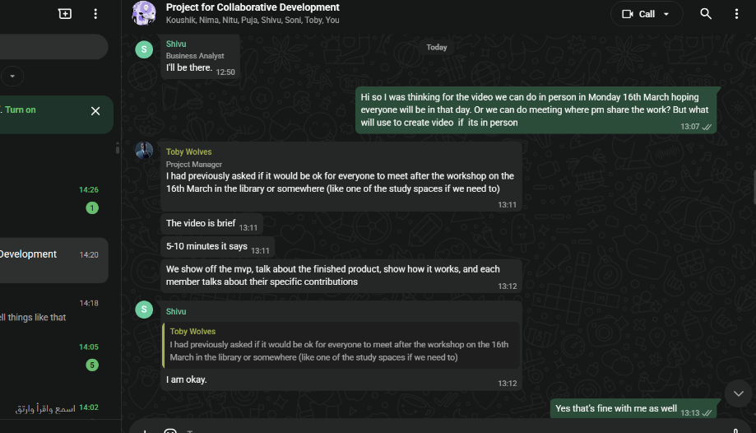
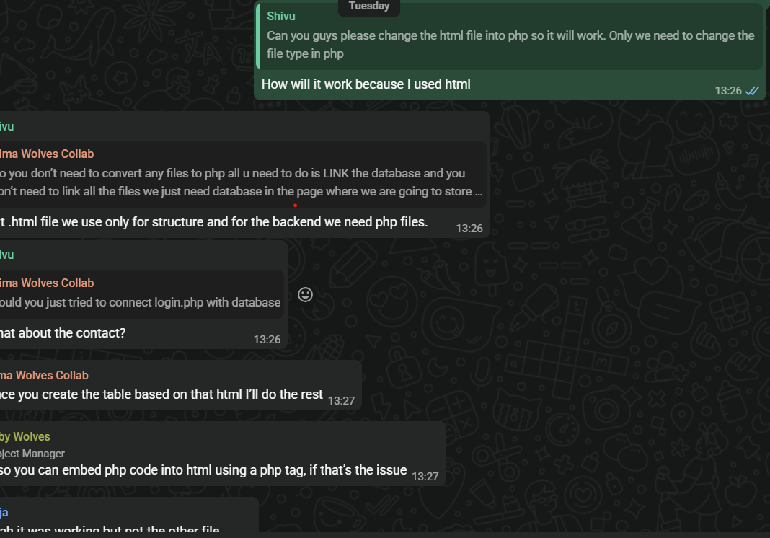
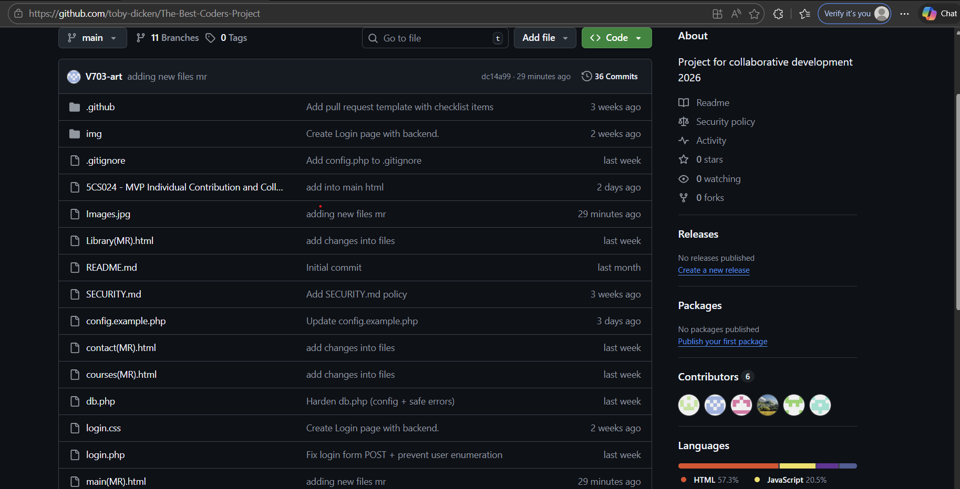

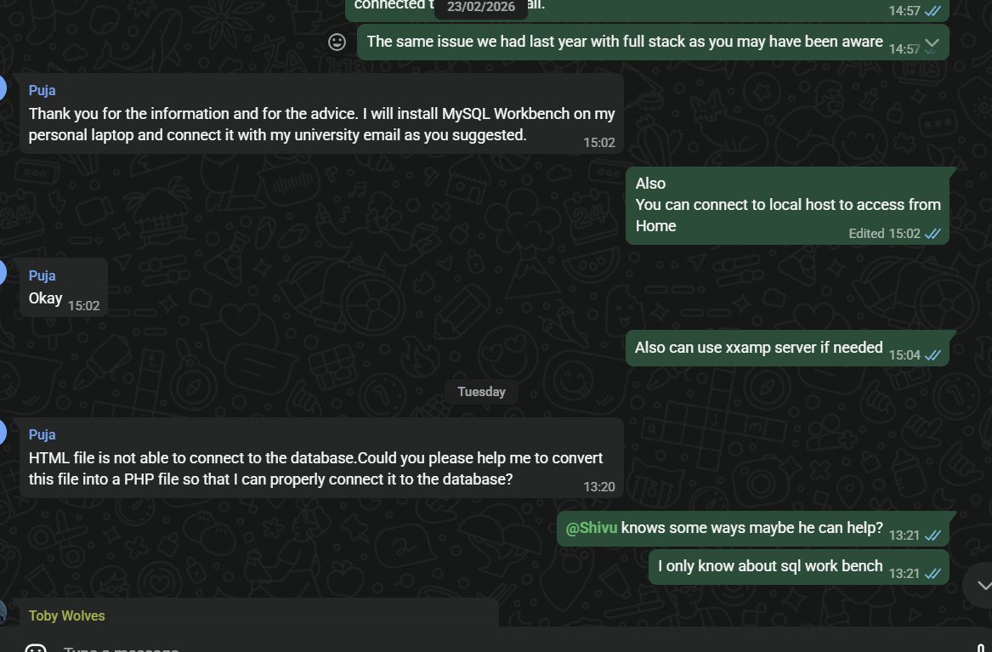
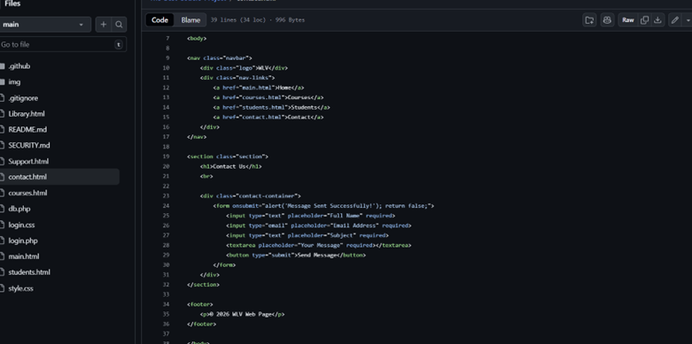

Issue tracking
Receivable evidence includes:
- Screenshots of personal contributions to GitHub issues.
Important: Please include no more than 5 items

